**Set up**

**Connect APM to computer**

Once you’ve downloaded Mission Planner onto your ground station computer, connect APM to your computer using the micro USB connector and APM’s micro USB port. [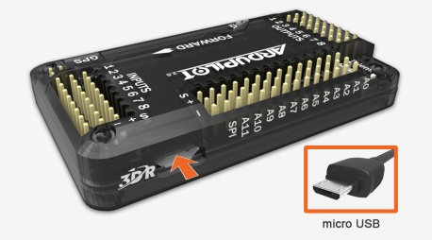](http://copter.ardupilot.com/wp-content/uploads/sites/2/2012/12/apm_micro_usb.jpg)

### Connect APM to Mission Planner

Next we’ll let Mission Planner know which port we’re using to connect to APM. In Mission Planner, use the drop-down menus in the upper-right corner of the screen (near the Connect button) to connect to APM. Select **Arduino Mega 2560** and set the Baud rate to **115200** as shown. Don’t hit **Connect** just yet.

[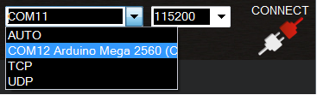](http://dev.ardupilot.com/wp-content/uploads/sites/6/2013/07/connect-to-com-port.png)

### Select firmware

Now we’ll select which firmware to download to APM; this depends on the configuration of your craft. Select the Hardware screen from the icons at the top of the display. Choose your copter’s frame by clicking the corresponding icon: Quad, Hexa, Y6, plane, rover, or other. (We’ll specify + or x configuration later.) The firmware screen will not appear if you have already selected Connect, so ensure that Mission Planner shows a disconnected icon in the upper-right corner to access the firmware.

[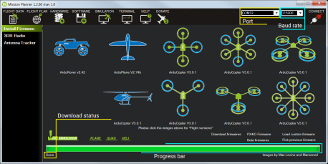](http://dev.ardupilot.com/wp-content/uploads/sites/6/2013/07/mission-planner-firmware-download.png)

Once you select your frame, Mission Planner will automatically detect the latest firmware version for your craft and prompt you to confirm the download. Select **Yes** to download the firmware onto APM. When the download status reads **Done**, your firmware download is complete.

[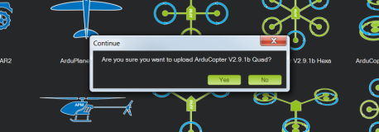](http://copter.ardupilot.com/wp-content/uploads/sites/2/2013/06/mission-planner-select-firmware.png)

### Connect to MavLink

Select **Connect** (upper-right corner of the screen) to load MavLink parameters to APM. Mission Planner will display a window showing the progress of the MavLink download.

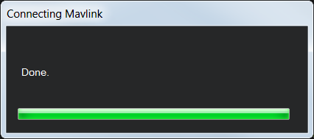

When the window displays **Done** and Mission Planner shows the **Disconnect** option in place of Connect, your APM firmware has been downloaded successfully.

[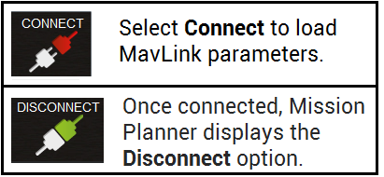](http://dev.ardupilot.com/wp-content/uploads/sites/6/2013/07/condiscon.png)